Exercise A :

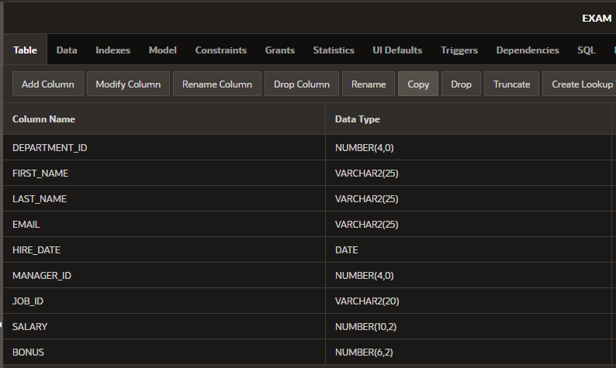

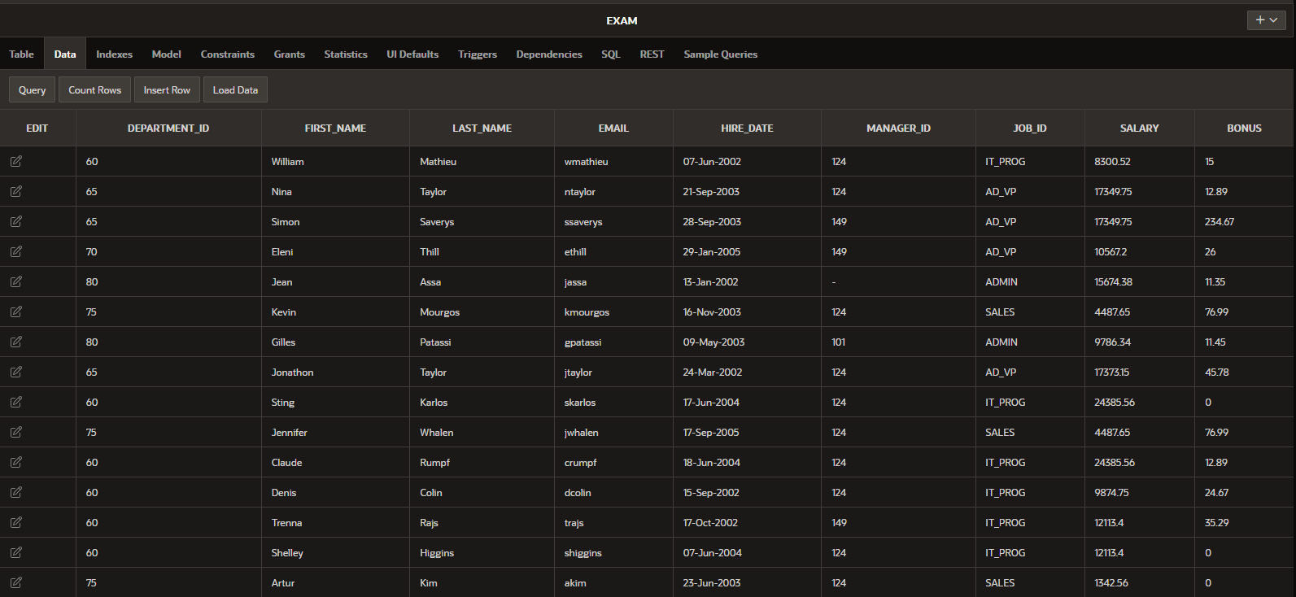

Exercise B :
- It’s correct : select * from EXAM
- It’s not correct : department_id= 60, or 70 is not valid : select AVG(salary) from EXAM where department_id in (60, 70)
- It’s not correct : the from is missing : select * from EXAM where job_id='IT_PROG'
- It’s not correct : select first_name, last_name, salary from EXAM where department_id=(select department_id from EXAM where last_name='Assa') you can’t put department_id=(select manager_id
- It’s not correct : you can’t do that : where department_id=(select department_id, manager_id :
- It’s not correct : the from comes after select and not after where: select salary from EXAM where department_id=80
- It’s not correct : you put the order by last: select first_name, last_name, salary from EXAM order by salary
- It’s not correct : you put the where last, after from
- It’s not correct : You can’t put: first_name, last_name and the max(salary) together.
- It’s not correct : you put the order by last, after from
- It’s not correct : you put the where after from, not before
- It’s correct : select last_name from EXAM order by salary

Exercise C:
- select first_name, last_name, salary, salary+salary*0.07 from EXAM
- select * from EXAM where job_id= :enter_job_id
- select last_name ||' '|| first_name ||' words in department '|| department_id from EXAM where manager_id in (124, 149)
- select last_name ||' '|| first_name ||' words in '|| job_id ||' department' from EXAM where job_id in ('IT_PROG', 'SALES')
- select first_name, last_name, salary, salary-salary*0.05 as "NEW_SALARY" from EXAM
- select * from EXAM WHERE job_id='IT_PROG' and salary > 15000
- select round(avg(salary), 2) from EXAM WHERE job_id='IT_PROG'
- select * from EXAM WHERE job_id='IT_PROG' order by salary desc
- select upper(first_name) ||' '|| upper(last_name) as "NEW", manager_id from EXAM where manager_id in (124, 149) or select upper(first_name) ||' '|| upper(last_name) as "NEW", manager_id from EXAM where manager_id=124 or manager_id=149
- select first_name, last_name, department_id from EXAM where manager_id= :enter_manager_id
- select first_name, last_name, department_id, job_id from EXAM where job_id= :enter_job_id
- select first_name, last_name, department_id, hire_date, salary from EXAM where manager_id= :enter_manager_id and hire_date <'01-May-2003'
- select first_name from EXAM order by first_name
- select substr(first_name, 1,1) ||''|| last_name, hire_date from EXAM where department_id=60
- select DEPARTMENT_ID, FIRST_NAME, LAST_NAME, EMAIL, HIRE_DATE, MANAGER_ID, JOB_ID, SALARY, BONUS+bonus*10 from EXAM where HIRE_DATE<'01-Jan-2005'
- select first_name, last_name, salary, hire_date from EXAM order by hire_date desc
- select first_name, last_name, salary, salary-salary*0.05 from EXAM where job_id='IT_PROG'
- select * from EXAM where hire_date between '01-Jan-2003' and '31-Dec-2004'
- select * from EXAM where last_name like 'K%' or last_name like 'T%' order by salary
- select * from EXAM where hire_date < '01-Jan-2004'

Exercise D:
- select first_name, last_name, salary from EXAM where salary> (select salary from EXAM where last_name like 'Patassi' )
- select* from EXAM where department_id= (select department_id from EXAM where last_name like 'Rajs' )
- select first_name, last_name, salary from EXAM where salary< (select avg(salary) from EXAM where job_id='AD_VP' )
- select first_name, last_name, salary from EXAM where hire_date> (select hire_date from EXAM where last_name like 'Higgins' )
- select first_name, last_name, salary from EXAM where job_id= (select job_id from EXAM where last_name like 'Higgins' )
- select first_name, last_name, salary from EXAM where salary< (select avg(salary) from EXAM where hire_date> (select hire_date from EXAM where last_name like 'Taylor'))
- select first_name, last_name, salary from EXAM where salary> (select avg(salary) from EXAM where department_id=60)
- select first_name, last_name, salary from EXAM where salary> (select min(salary) from EXAM where hire_date> (select hire_date from EXAM where last_name like 'Kim'))
- select first_name, last_name, salary, job_id, department_id from EXAM where job_id= (select job_id from EXAM where last_name like 'Kim')
- select first_name, last_name, salary from EXAM where department_id= (select department_id from EXAM where last_name like 'Taylor')
- select first_name, last_name, salary, salary+500 from EXAM where hire_date> (select hire_date from EXAM where last_name like 'Whalen')
- select first_name, last_name, salary from EXAM where salary> (select avg(salary) from EXAM where department_id in (60, 65))
- select first_name, last_name, salary from EXAM where salary> (select avg(salary) from EXAM where job_id in ('AD_VP', 'IT_PROG'))
- select first_name ||' '|| last_name ||' '|| salary as "Information" from EXAM where hire_date< (select hire_date from EXAM where last_name like 'Higgins')
- select upper(first_name), upper(last_name) as "Name" from EXAM where job_id= (select job_id from EXAM where last_name like 'Assa')
- select first_name, last_name, salary from EXAM where department_id= (select department_id from EXAM where last_name like 'Colin') order by salary
- select first_name, last_name, salary, hire_date from EXAM where hire_date> (select hire_date from EXAM where last_name like 'Kim') order by hire_date
- select first_name, last_name, salary-200, hire_date from EXAM where hire_date> (select hire_date from EXAM where last_name like 'Colin')
- select last_name, hire_date, department_id from EXAM where salary> (select salary from EXAM where last_name like 'Kim') order by hire_date
- select first_name, last_name, salary from EXAM where department_id= (select department_id from EXAM where first_name like 'Nina') order by salary
- select first_name, last_name, salary, hire_date from EXAM where hire_date> (select hire_date from EXAM where first_name like 'Nina') order by salary
- select * from EXAM where salary> (select avg(salary) from EXAM where job_id in ('ADMIN', 'AD_VP'))
- select first_name ||' '|| last_name as "Name" from EXAM where job_id= (select job_id from EXAM where last_name like 'Mourgos')
- select last_name, salary from EXAM where salary> (select min(salary) from EXAM where department_id=80)
- select first_name, last_name, salary from EXAM where department_id= (select department_id from EXAM where last_name like 'Thomas') order by salary desc
- select last_name, salary+salary*0.10, department_id from EXAM where department_id= (select department_id from EXAM where last_name like 'Thomas') order by salary desc
- select last_name, salary, salary-salary*0.03 from EXAM where hire_date> (select hire_date from EXAM where last_name like 'Whalen')
- select last_name, salary, salary-300 from EXAM where job_id= (select job_id from EXAM where last_name like 'Rajs')
- select upper(first_name) from EXAM where department_id= (select department_id from EXAM where last_name like 'Assa')
- select last_name, hire_date from EXAM where salary>7000 order by last_name

Exercise E:
- select next_day(sysdate, 'Wednesday') from Dual
- select last_day(sysdate) from Dual
- select substr('project', 2, 4) from Dual
- select trim('a' from 'aacbbraa') from Dual
- select instr('This is first project', 's') from Dual
- select 'Oracle' || ' ' || 'Internet' || ' ' || 'Academy' from Dual
- select substr('Oracle Internet Academy', 13, 3) from Dual
- select Lpad(Rpad('Oracle Internet Academy', 27, '*'),31, '&' ) from Dual
- select replace('Oracle Internet Academy', 'Internet', '2022-2023' ) from Dual
- select trunc(86.6272, 1) from Dual

